Krystal Olsen
GCU 114
04/07/2015

Over the course of history in Morocco, there have been many cultural influences from different ruling countries. People who ruled Morocco at one point in time such as the Romans, the French, the Spaniards, the Jews and the Arabs have all had their own cultural impact on Moroccan culture today. All of these countries cultures influence have helped turn Morocco into one of the most vibrant cultures known today. Morocco may seem like they are a very diverse culture, however, to outside cultures other than Moroccan sometimes may be unwelcoming.
Moroccans believe that modernization could ruin their strong culture. Modernization is important to have the most updated and respectful form of ones culture. Morocco being a patriarch where men have power above women, this is considered to be a part of their culture. Women should be treated equally no matter what the tradition of a countries culture states. This lack of societal advancement leads to the culture of Morocco being viewed as negative for women. If Morocco treated women in their culture equally as they do men, this would be a more welcoming culture to outsiders and still does not interfere with traditions of their overall culture.
In the education system, Morocco is not open to different languages that students speak in the country. In the article, “The Price of Diversity in Morocco”, Abdellah Taibi states “More than 50 percent of Moroccans speak Amazigh language as their mother tongue and the rest speak Darija, an Arabic dialect, while education utilizes classical Arabic as a language for teaching and learning.” This means that the education system has not changed to adjust to student’s languages in order to try to keep the classic of Moroccan culture. This could be an effort to maintain culture in the country but when it is affecting the learning of their children it should be acknowledged as an issue. In a country that has a history of poor education, they should be focusing on helping more students pass and learn by adjusting the main language instead of trying to preserve the culture of their ancestors.
The government of Morocco also has issues with the increase of social media and its freedoms. In the article “Media in Arab countries lack transparency, diversity and independence” Angelika Mendes discusses how Morocco has made many positive changes to promote civil and political culture among the country. On the other hand, Morocco has issues with freedoms of the Internet. ““Morocco adopted a new constitution, we had elections and we now have a new government”, he added. However, some bureaucrats within the government seem to block efforts to increase media freedom.” This quote from the article explains how Morocco did make changes in their culture of media to adjust to changes in society but are not acknowledging the freedoms of social media, which is popular among the younger generations of the country. Being that most of Morocco’s population is in its twenties, the government should be more open to making these changes to allow freedom on the Internet.
As seen in the picture below, we have a map of the world and how diverse their countries are. Morocco claims to be extremely diverse but compared to most other countries in Africa, it is just averagely diverse. 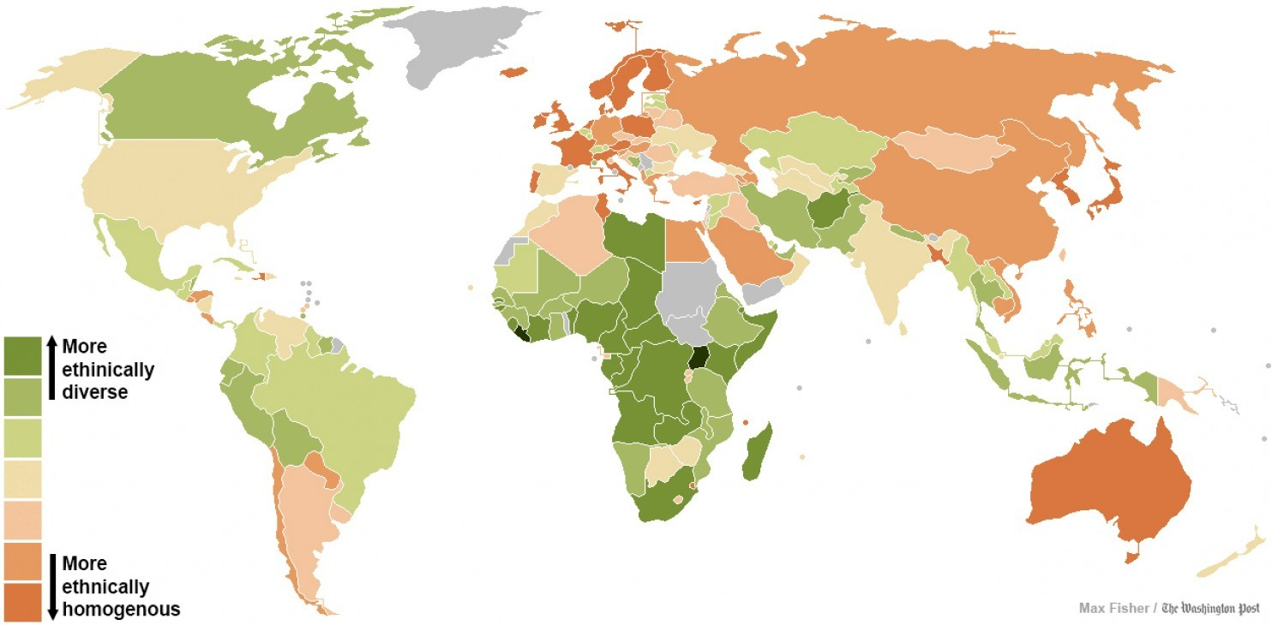
Moroccan culture is one of the many unique and vibrant cultures in the world. Be that as it may, it is not one of the most diverse cultures. Based on the areas previously discussed, Morocco can make many changes to help make their culture more accepting of others and changes occurring in the world’s society.
Cited Sources:

“Cultural Diversity in Morocco” Retrieved on April 7th 2015
http://www.morocco.com/blog/cultural-diversity-in-morocco-an-omnipresent-history
“Moroccan Culture” Retrieved on April 7th 2015
http://www.everything-moroccan.com/moroccan-culture.html
Taibi, Abdellah “The Price of Diversity in Morocco” March 2nd 2013
http://www.moroccoworldnews.com/2013/03/80684/the-price-of-diversity-in-morocco/
Mendes, Angelika “Media in Arab countries lack transparency, diversity and independence” June 25th 2012
http://www.kas.de/wf/en/33.31742/
“Revealing Map of the worlds most and least ethnically diverse countries” Image retrieved on April 7th 2015
http://www.washingtonpost.com/blogs/worldviews/wp/2013/05/16/a-revealing-map-of-the-worlds-most-and-least-ethnically-diverse-countries/

