Krystal Olsen
GCU 114

Education in Morocco
In the country of Morocco, education is an option for all children. It is free until children reach the age of fifteen. Although education is available to most children and ninety percent are enrolled, many do not attend. This may be a negative aspect of the education system, however, Morocco has come very far since 1963 when schools were first made compulsory.
Children begin school at age six and start with primary education. Once they turn 12, they continue on to a secondary education. They go to three years of what we consider a “middle school”. Once they complete those three years they choose what kind of specialized education they would like to receive. This secondary education option prepares them for what they would like to study in college for the few who continue on into college.
After primary schooling many students, especially girls, end up dropping out of school. This is an issue in the education system of Morocco because many women are not receiving the proper education to be considered equal to men. About sixty-eight percent of women from the ages of 15-24 are able to read and write, compared to eighty-five percent of men the same age group (Our Africa, 2008).
Children in Morocco face language barriers in their schooling due to the Berber dialects that are spoken in most areas. Schools in Morocco either teach in standard Arabic, French or English. Struggling with communication does not help aid in children wanting to drop out or not continue their education to a higher standard.
Unemployment rates have lowered in the past few decades, but there is still a shortage of jobs in the country. In the picture below from Find the Data, you can see since 1996, the unemployment rate has dropped from about sixteen percent to eight percent.
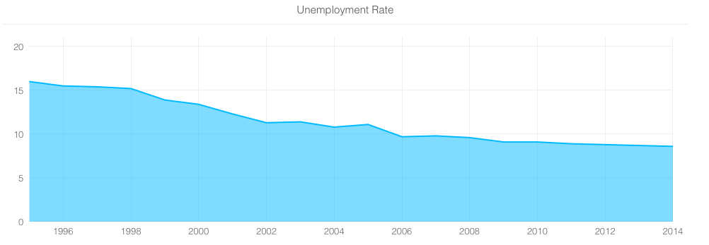
Although this is a great decrease, most of this comes from elder people in the population receiving employment. The younger population have a harder time getting jobs even with a higher form of education which causes many young people to leave the country to find better opportunities elsewhere.
Morocco should be attending to these problems in their education on a need basis. Their quality of education should increase so that more students will be inspired to go to college and they can expand on their universities and help create more jobs. In the article “Crossing the Bridge from Education to Employment” Emily Kingsland discusses research done comparing other countries job readiness once students are finished with college. In the chart below, you can see that Morocco is at the bottom of the countries researched in provider perspective, employer perspective and difference (2013).
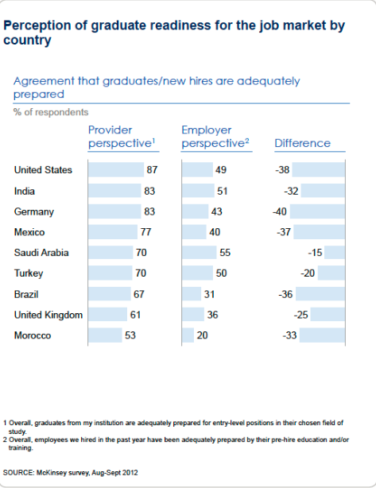

Sources:

“Morocco” Find the Data. Retrieved on March 24th 2015
http://country-facts.findthedata.com/l/145/MA

“Morocco, Education and Jobs” Our Africa 2008 Retrieved on March 24th 2015 http://www.our-africa.org/morocco/education-jobs

“Crossing the Bridge from Education to Employment” Kingsland, Emily 2013 Retrieved on March 24th 2015
http://www.ncee.org/2013/01/international-reads-crossing-the-bridge-from-education-to-employment/

