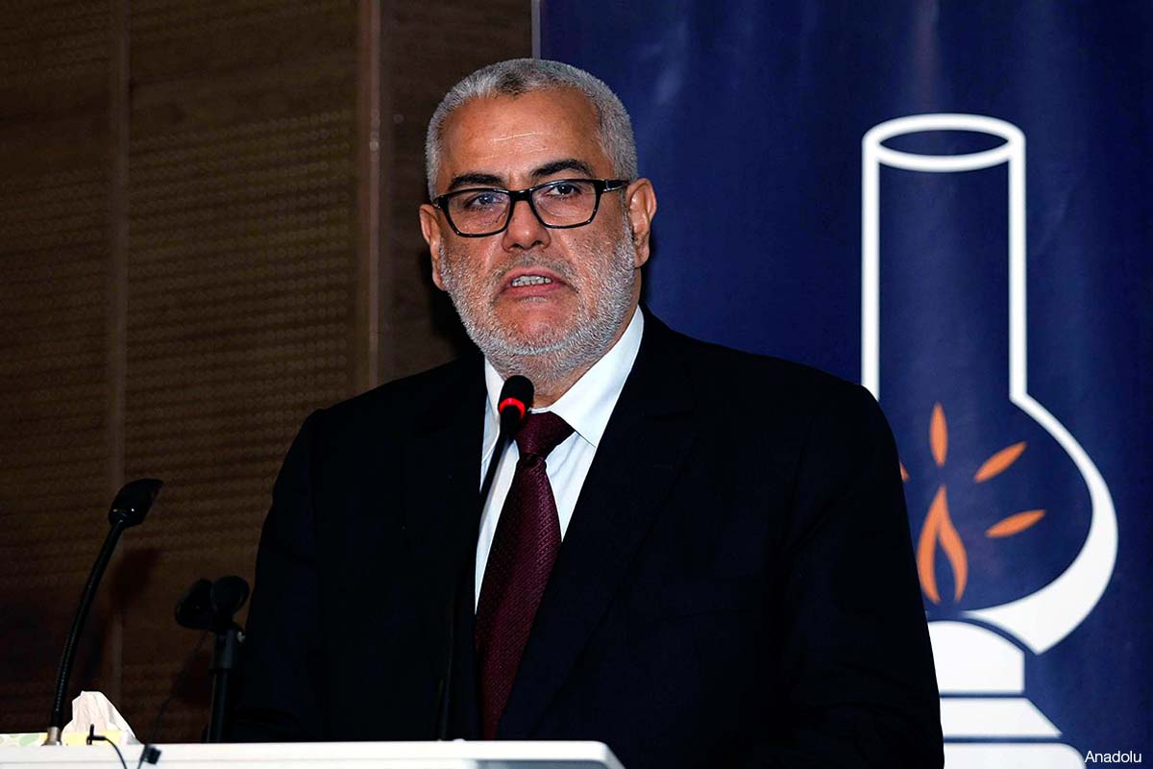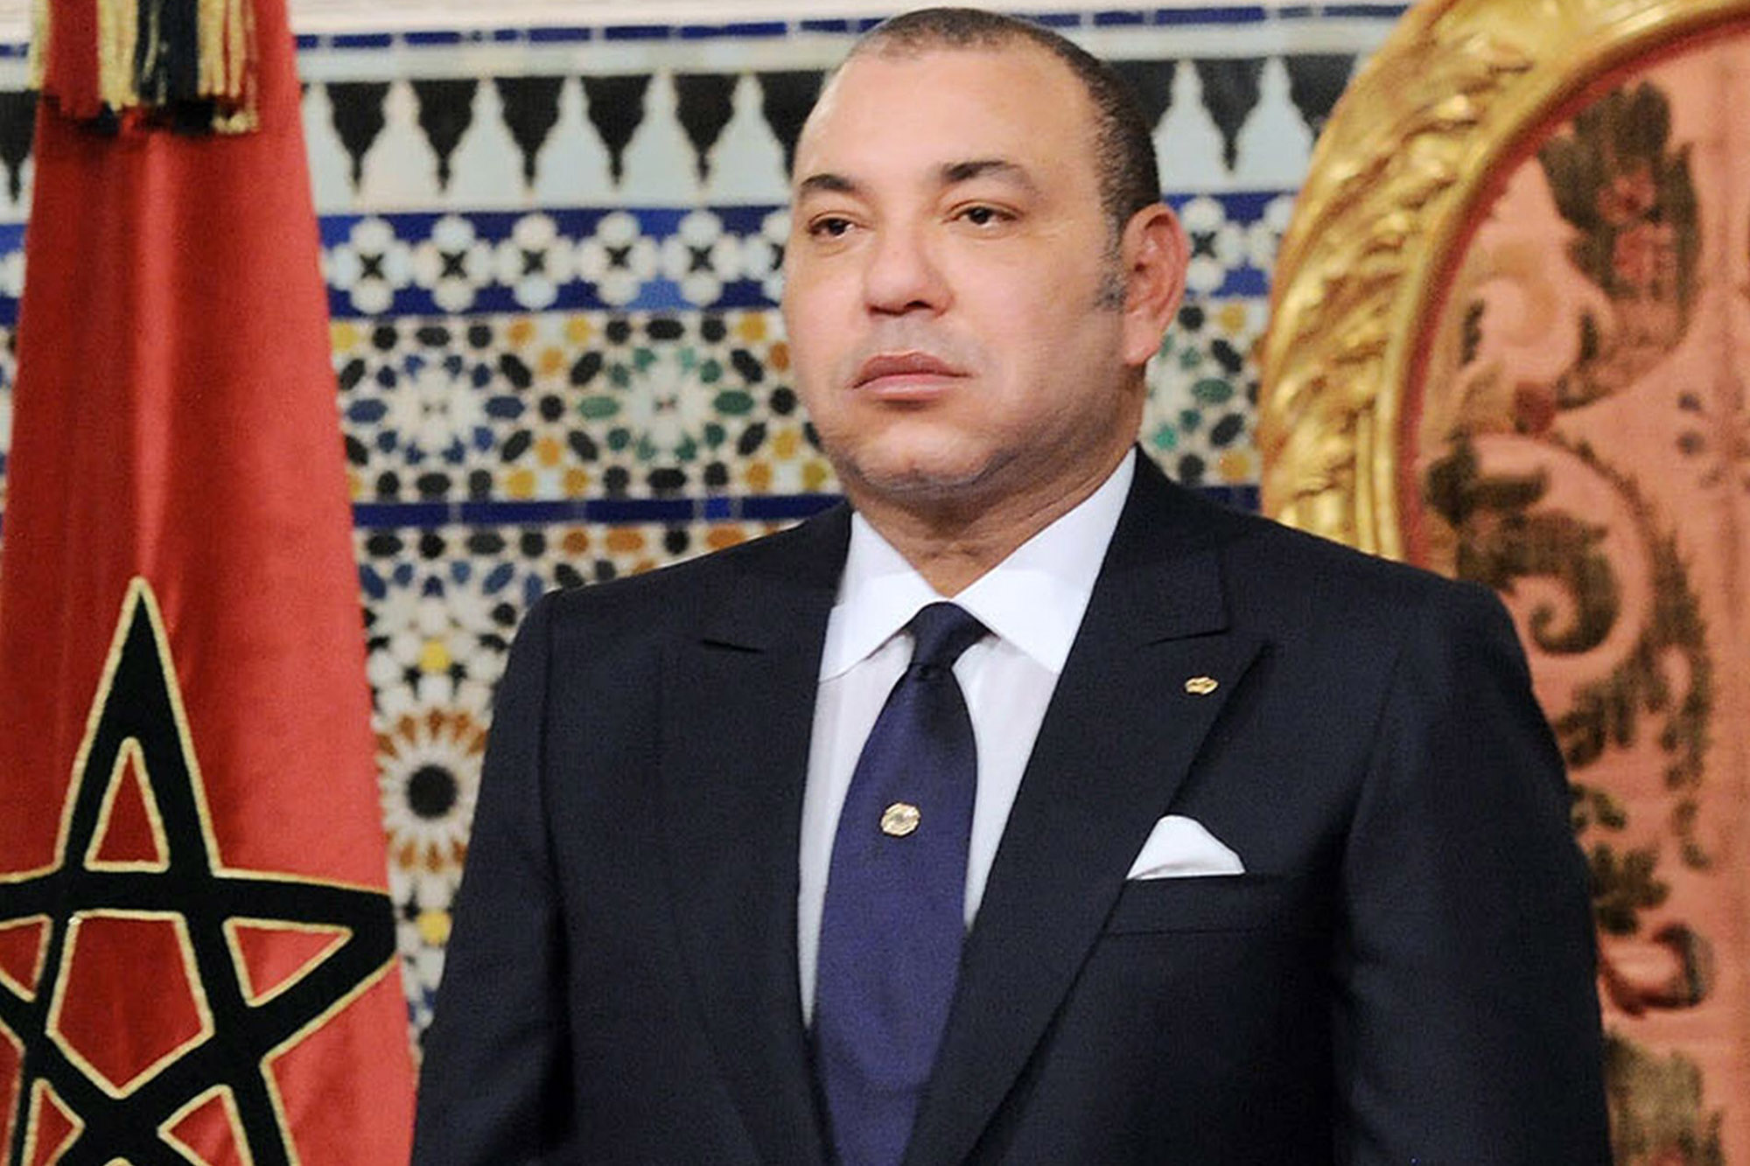

Abdelilah Benkirane

* Prime Minister/Head of Government
* 60 years old
* Has democratic views for Morocco despite the monarchy

King Mohammed VI

* 51 years old
* Appointed in July of 1999 after the death of his father
* Chief of State
* His birthday is a national holiday

On March 2nd 1956, Morocco claimed its independence from France’s monarchy. Morocco is still a monarchy, which means it is ruled by a king who is appointed because of his hereditary obligations. The king appoints the Prime Minister who is second in command in the country. The King and Prime Minister have a council of Ministers to help delegate laws for the country. Morocco also has a supreme court that consists of 5 judge panels of different legal issues.

### Morocco is a Constitutional Monarchy.